## IGI 2 COVERT STRIKE

In this sequel you play as ex-SAS soldier David Jones who is fighting a war against terrorists. This game is the second part of the game Project: I’m Going In (IGI)

# Characters

1. DAVID JONES-

Born in Cardiff in 1965. After spending a short period in a youth detention centre, he immediately joined the British Army. Plenty of hard work and training defined him as one of the most highly regarded NCO’s in the parachute regiment. Shortly after his sixth year service he applied to join the Special Air Service Regiment. He left the regiment after three years due to an injury.

1. REBECCA ANYA-

She gives advises to Jones by ear transmitter. She shows him where he should go and how through satellite video streaming.

1. PHILLIP WHITE-

He was the first mission director of Jones but he betrays him and acquires the EMP’s. He along with Quest had been loyal to Wu Xing but he was killed by Wu Xing.

1. ROBERT QUEST- The first pilot of Jones. Jones himself killed him at Showdown at the Docks for betraying him.
2. Major Lennahan
3. Jach Priboi – An old friend of Jones.
4. Major Zaleb Said – He stole data from Priboi’s Computer after kidnapping him. He is one of the main antagonist.
5. Wu Xing – The main antagonist of the game who wants to start World War 3. Xing has siphoning funds with the Chinese Space Research Centre.
6. 2nd pilot of Jones
7. Russian terrorists
8. Libyan terrorists
9. Chinese terrorists
10. Terrorists programmers
11. IGI 2 backup team

# Game levels

RUSSIA

1. INFILTRATION
2. DEEP IN THE MINES
3. THE WEATHER STATION
4. BRIDGE ACROSS THE DNESTR
5. AMBUSH
6. 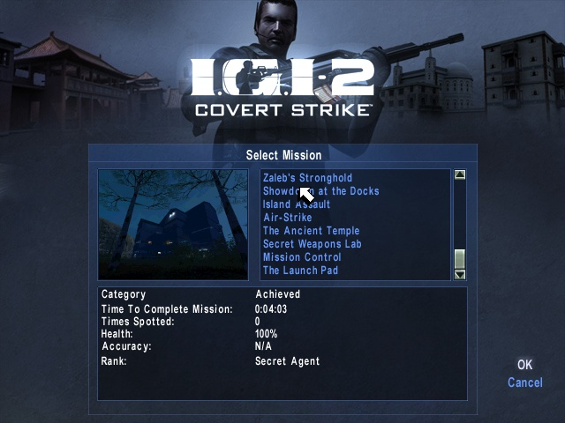PRODUCTION FACILITY
7. BORDER CROSSING

LIBYA

1. LIBYAN RENDEZVOUS
2. PRISON ESCAPE
3. PRIBOI’S VILLA
4. THE AIRFIELD
5. ZALEB’S STRONGHOLD
6. SHOWDOWN AT THE DOCKS

CHINA

1. ISLAND ASSAULT
2. AIR-STRIKE
3. THE ANCIENT TEMPLE
4. SECRET WEOPENS LAB
5. MISSION CONTROL
6. THE LAUNCH PAD

# PLAYABLE WEOPENS (INCLUDING MULTIPLAYER WEOPENS)

* Knives: [Combat Knife](http://igi.wikia.com/wiki/Combat_Knife)
* Side arms:   [G17SD](http://igi.wikia.com/wiki/G17SD),   [Makarov](http://igi.wikia.com/wiki/Makarov), [SOCOM](http://igi.wikia.com/wiki/SOCOM), [Desert Eagle](http://igi.wikia.com/wiki/Desert_Eagle), [SMG-2](http://igi.wikia.com/wiki/SMG-2), [Colt Anaconda](http://igi.wikia.com/wiki/Colt_Anaconda)
* Sub machine Guns:  [MP5A3](http://igi.wikia.com/wiki/MP5A3), [MAC-10](http://igi.wikia.com/wiki/MAC-10), [MP5SD3](http://igi.wikia.com/wiki/MP5SD3), [Uzi](http://igi.wikia.com/wiki/Uzi), [T64](http://igi.wikia.com/wiki/T64)
* Assault Rifles:  [AK-47](http://igi.wikia.com/wiki/AK-47), [M16A2](http://igi.wikia.com/wiki/M16A2), [G-36](http://igi.wikia.com/wiki/G-36), [AUG](http://igi.wikia.com/wiki/AUG), [G11](http://igi.wikia.com/wiki/G11)
* Sniper Rifles:   [PSG-1SD](http://igi.wikia.com/wiki/PSG-1SD), [SVD Dragunov](http://igi.wikia.com/wiki/SVD_Dragunov), [PSG-1](http://igi.wikia.com/wiki/PSG-1), [M82A1-T](http://igi.wikia.com/wiki/M82A1-T), [M82A1](http://igi.wikia.com/wiki/M82A1)
* Shotguns: [SPAS-12](http://igi.wikia.com/wiki/SPAS-12), [Jackhammer](http://igi.wikia.com/wiki/Jackhammer), [M1014](http://igi.wikia.com/wiki/M1014)
* Heavy Weapons:   [FN Minimi](http://igi.wikia.com/wiki/FN_Minimi), [RPG-7](http://igi.wikia.com/wiki/RPG-7), [M2HB](http://igi.wikia.com/wiki/M2HB), [LAW 80](http://igi.wikia.com/wiki/LAW_80)
* Explosives:  [Hand Grenade](http://igi.wikia.com/wiki/Hand_Grenade), [CR-4 explosives](http://igi.wikia.com/wiki/CR-4_explosives)

# VEHICLES IN IGI 2 (UNUSABLE BY USER)

1. Jet Fighter Plane
2. Chopper
3. Mini Train
4. Limousine
5. Army Tanks/APCs
6. Trucks
7. Ekranoplane (Water Vehicle)
8. Rocket Missile